**Lutezine to Lute News 111 (October 2014): Santino Garsi da Parma (1542-1604), Ascanio and Donino Garsi, Balletto detta la mezza pace & Albert de Rippe Part 3: Fantasies No 22-24**

**SANTINO GARSI DA PARMA (continued)**[1]

The remaining ascribed lute solos of Santino are included in this *Lutezine*,[2] one version of each (except for no 30 for which all versions are included): four Ballo/Balletto, arrangements of the popular Italian tunes Aria/Ballo del Gran Duca/di Firenze[3] and Ruggiero,[4] a Correnta (arranged or composed by Santino), a Rotta, and three doubtful items, in which his name is either crossed out or added together with that of Lorenzino in the unique sources: two gagliarda and a long capriccio (reminiscent of Dowland's fantasias in places!). These are followed by seven anonymous gagliarda in Santino's style that could have been composed by Santino or by others within his sphere of influence: one from the Barbarino MS, four from Galilei's manuscript where they are interdigitated with the many anonymous items concordant with Santino's music elsewhere (see *Lute News*), one from a print of Waissel (the least likely to be Santino, although I did identify a concordance for Santino no 5 in another German lute print, Denss' *Florilegium* - see Lute News) and no vii which is a transposed version of Santino no 5 from a German manuscript that wasn't recognized in time for inclusion in *Lute News* 110. Many other versions of Santino's music are corrupt, mainly due to Santino's often complex rhythms that copyists did not always notate accurately. Surprisingly, despite the quantity and appeal of Santino's music, it is not well represented on CD.[5] Donini did not seem to inherit Santino's flair for composition, as the thirteen solos in a variety of genres for 13-c archlute ascribed to him are not of a high standard but are nevertheless all reproduced here, plus the one solo bearing the name Ascanio Garsi which he almost certainly borrowed from [Ennemond?] Gauthier.

**24i-ii.** PL-Kj mus.40153 (Dusiacki), ff. 70r-70v *Ballo del Seren(issi)mo* ***Duca di Parma****[6] fatto da Santino Garsi* K21; OIII/6

**25**. PL-Kj mus.40153, ff. 62v-63r *Balletto di Santino* K19; OIII/4

D-W Guelf.18.7/II (Hainhofer), f. 106v *Canzonetto*

**26.** PL-Kj mus.40153, ff. 65v-66r *Balletto di Santino*

*Garsi di Parma* K20; OIII/5

**27.** B-Br II.275 (Cavalcanti), f. 12r *Morescha* [index: *B*(allett)*o* *morescha di santino Da Par*(m)*a* K25; OII/3

I-Fn Gal 6, p. 255 ii *La moresca*

**28i-ii.** PL-Kj mus.40153, ff. 7v-8r *Aria del Gran Duca fatta da Santino Garsi* K17; OIII/2 & OIV/2

**29.** B-Br II.275, ff. 94r-95v *Ruggieri di Sa*(n)*tino da Parma / Ruggieri S*(igno)*r Santino* [index: *Ruggieri Di Santino Da Parma*]K40; OII/17

I-Fn Gal 6, p. 249 *Ruggieri*

**30a.** PL-Kj 40153, f. 4v *Co*[r]*renta di santino Garsi da Parma* K16; OIII/1

**cognates in F:**

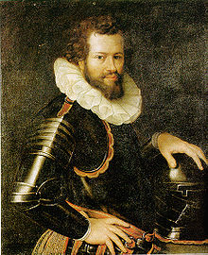

Ranuccio Farnese,

Duke of Parma

**b.** D-Kl 4o.108.1, f. 25v untitled

**c.** Valerius 1626, pp. 52-53 *Fransche Courante*

**d.** S-S 2245 (Beckman), ff. 3v-4r *Courant*

**e.** Besard 1603, f. 153v *Courante*

**f.** Fuhrmann 1615, p. 174 *Courante 19*

**g.** GB-Cu Dd.5.78.3, f. 74v *Curranta*

**h.** GB-Cu Dd.9.33, f. 42v *Curranta*

**i.** GB-Ctc O.16.2, pp. 126-125 *A corranto*

**j.** GB-Lbl Add.38539 (ML), f. 3v *Brettes Corante* [7]

**k.** GB-Eu Laing III.487 (Rowallan), p. 3 *Curent*

**l.** GB-En Dep.314 no.23 (Wemys), f. 19v *the giuens corant*

**cognates in C:**



Ferdinando Gonzaga, Duke of Mantua

**m.** GB-Cu Dd.9.33, f. 58r *Currant*

**n.** GB-HAdolmetsch II.B.1, f. 34r *Courante*

**o.** GB-HAdolmetsch II.B.1, ff. 22v-23r *Courante*

**p.** D-Mbs 21646 (Werl), f. 91v ii *Corente*

**q.** US-SFsc M2.1 M3 (de Bellis), p. 39 *Corente*

*in basso*

**cognates in Bflat:**

**r.** F-Pn Rés.1108, f. 46r *Correntta*

**s.** CZ-Pnm IV.G.18 (Rettenwert), ff. 132v-133r *Curante*

**t.** Fuhrmann 1615, p. 124 *Courant*

**u-i.** GB-HAdolmetsch II.B.1, f. 283v *Courante a corde avalle* (fefhf)

**u-ii.** GB-HAdolmetsch II.B.1, f. 283v *Courante* transcribed

[Additional cognates: D-B 40141, f. 256v *Currandt*; D-B Danzig 4022, f. 40v *Current*; D-KNa W 4o 328, f. 8v *Courant* (in LZtoLN115); D-KNu K 16a 6745 qu, p. 3 ii *Couran*; D-LEm II.6.15, p. 259 *Current*; D-W Guelf.18.8, f. 289r *Une courante française Joan: Perrichon* (in LN114; Valerius 1626, p. 52 *Fresche Courante*; Praetorius 1612, no. 150 *CL. à 4. Courante M.M. Wüstrow. M.P.C*. à 4; no. 153 *Courante MPC à 4*]

**31.** D-Sl G.I.4 III, ff. 25v-26r *Capriccio de S(igno)r Santino da Parma*/ *Fantasia di M Lorenzino Romanese /* in Hebrew: *Kowalis Lorenzo*

Carlone,[8] no 76

**32.** D-W Guelf.18.8 (Hainhofer), ff. 212r-213r *Rotta di Santino*

**33.** PL-Kj 40032 (Barbarino), p. 313 *Gagliarda di* *~~Santino~~* OI/10

**34.** PL-Kj 40032, p. 361 ii *Gagliarda di ~~Lorenzino~~ Santino*

Carlone, no 18; Kapp; OI/19

**Anonymous but similar to Santino's style**[9]

**i.** Waissel 1591, sig. I4r *Gailliarda 3*



Charles III,

Duke of Lorraine

**ii.** I-Fn Gal 6, p. 254 iii *21* (Gagliarda)

**iii.** I-Fn Gal 6, p. 247 ii *10*  (Gagliarda) *L'Imperiale*

**iv.** I-Fn Gal 6, p. 251 i *13* (Gagliarda)

**v.** PL-Kj 40032 (Barbarino), p. 322 *Gagliarda del*

***duca di Lorena****[10]*

**vi.** I-Fn Gal 6, p. 250 i *11* (Gagliarda) *Agostina*

**vii.** D-Sl G.I.4 II, f. 80r *Gagliarda* cf. Santino no 5

**Ascanio and Donino Garsi da Parma** [11]

**Donino**

**1.** PL-Kj 40153, ff. 67r-68r *Preludio di Donino* OIII/17

**2.** PL-Kj 40153, ff. 64v-65r *Toccata di Donino Garsi* OIII/14

**3.** PL-Kj 40153, ff. 70v-71r *Sop*(r)*a il Ballo del S*(erenissimo).

*Duca di me Donino Garsi* OIII/19

**4**/**JD54h.** PL-Kj 40153, ff. 59v-60r *Balletto di me Donino*

*Garsi fatto per il S*(erenissimo). ***Duca di Mantua*** [12] OIII/12

**5.** PL-Kj 40153, ff. 63v-64v *Pauana in soprano di Donino Garsi* OIII/13

**6.** PL-Kj 40153, ff. 8v-9r *Gag*(liar)*da di Donino Garsi da Parma* OIII/9

**7.** PL-Kj 40153, ff. 9v-10r *Gag*(liar)*da di Donino* OIII/10

**8.** PL-Kj 40153, f. 3r *Gag*(liar)*da di Donino Garsi da Parma* OIII/7

**9.** PL-Kj 40153, f. 11r *Gag*(liar)*da di Donino* OIII/11

**10.** PL-Kj 40153, f. 65r *Gag*(liar)*da di Donino Garsi* OIII/15

**11.** PL-Kj 40153, f. 66v *Gagliarda di Donino Garsi* OIII/16

**12.** PL-Kj 40153, f. 69r *Folia di Donino Garsi* OIII/18

**13.** PL-Kj 40153, ff. 5v-7r *Battalia di Donino Garsi da Parma* OIII/8

**Ascanio**

**1a.** PL-Kj 40153, f. 15v *Corenta* [below: *a di primo di*

*febraio 1621 Ascanio Garsi*] OIII/20

**1b.** CH-Bu F.IX.53, ff. 18v-19r *Courante de Gauthier* Goy[13] VI.A38

I-Tn, IV.23/2 ff. 10v-11r *Courente*; I-PEas VII-H-2, p. 99 *Corr: franc.*; RUS-SPan O N° 124, ff. 67v-68r *Corente*

**APPENDIX TO JOHN DOWLAND SERIES PART 12** [14]

To accompany the concordant versions of John Dowland's Lady Hunsdon's Puffe in *Lute News* 111 (DowlandCLM 54, JD54a-e), all ten cognates of the related Italian model (JD54f-o) are included here. These represent a wide range of settings of much the same material usually in five sections with or without repeats (the A repeats down an octave in m and all repeats down an octave in n], and the B sections of 6 or 12 bars and the other sections 4, 8 or 16 bars. Only the 1st, 2nd and 5th sections were arranged by Dowland, and interestingly by Donino too. Arguments for assuming neither Dowland nor Donino composed the original are in the tablature supplement to *Lute News.*

**JD54f.** NL-DHnmi Kluis 1 (Siena), f. 113v untitled

**JD54g.** US-BE 757, f. 1v *La Megia Pase Francesa*

**JD54h/Donino 4.** PL-Kj Mus.40153, ff. 59v-60r *Balletto di me Donino Garsi fatto per il S*(erenissimo)*. Duca di Mantua*

**JD54i.** D-LEm II.6.15, p. 454 *Mein zung zu exprimiren*

**JD54j**. D-LEm II.6.15, p. 499 *Anglicum*

**JD54k.** US-SFsc M2.1 M3, p. 79 *Gagliarda*

**JD54l.** CZ-Pnm IV.G.18, ff. 138v-139r untitled

**JD54m.** I-GBDchilesotti, p. 213 *Pezzo Italiano* (= Italian piece)

**JD54n.** US-SFsc M2.1 M3, pp. 26-27 *Gagliarda deta la mezza pace*

**JD54o.** US-BE 760, f. 17r *Baleto in Soprano* [incomplete]

**ALBERT DE RIPPE/ALBERTO RIPA**[15]

This supplement ends with the third part in the series of the complete fantasies of Alberto da Ripa/Albert de Rippe, reproducing three of the five fantasies from *Quart Livre de Tabulature de Leut* (Paris, Le Roy and Ballard 1553), no 22-24.[16] The first two were also included in virtually identical versions in *Thesaurus Musicus* (Louvain, Phalèse & Bellère, 1574 [Brown 15747]), but no other concordances for the three are known and they were not included in the Morlaye/Fezandat printed series. Page 4 here shows the title pages for all the surviving prints of de Rippe's music published by Fezandat and Le Roy & Ballard (the Fezandat book III is missing). Incidentally, I can think of no lute music more sublime than bars 163-196 of Fantasie 22, although the left hand fingering of the unique chords is unusually difficult to master!

**Rippe 22**. *Fantasie* Le Roy & Ballard IV 1553, ff. 8r-10v

*Fantasie 5* Phalèse & Bellère *Thesaurus Musicus* 1574, ff. 9r-10v

**Rippe 23.** *Fantasie* Le Roy & Ballard IV 1553, ff. 10v-13v

*Fantasie 6* Phalèse & Bellère 1574, ff. 11r-12v

**Rippe 24.** *Fantasie* Le Roy & Ballard IV 1553, ff. 13v-15r

*John H Robinson - October 2014*

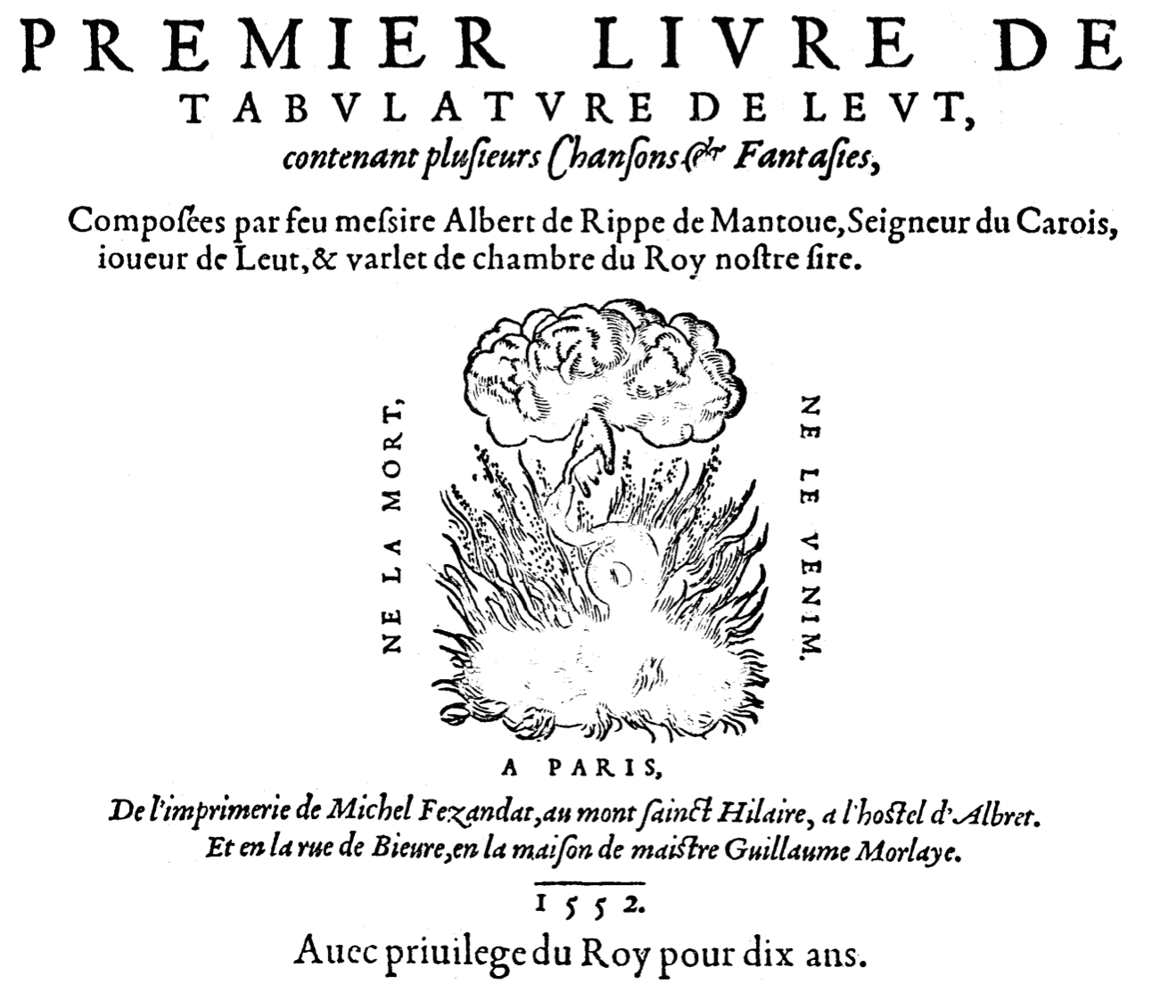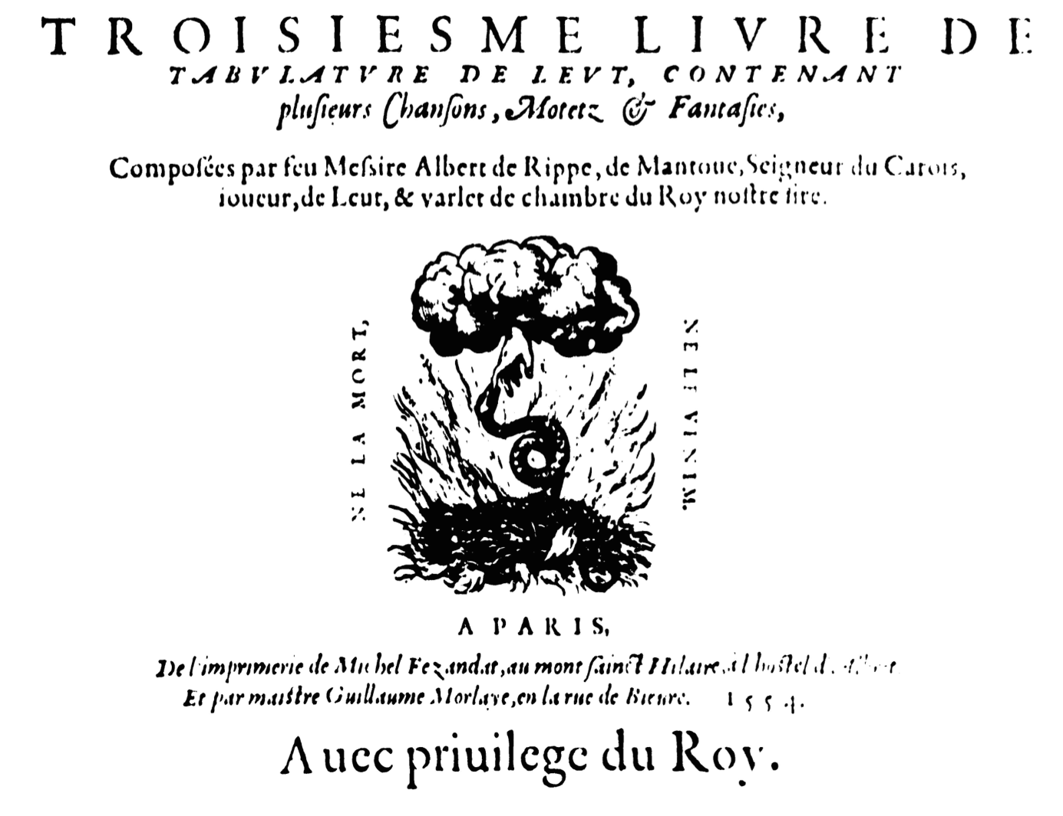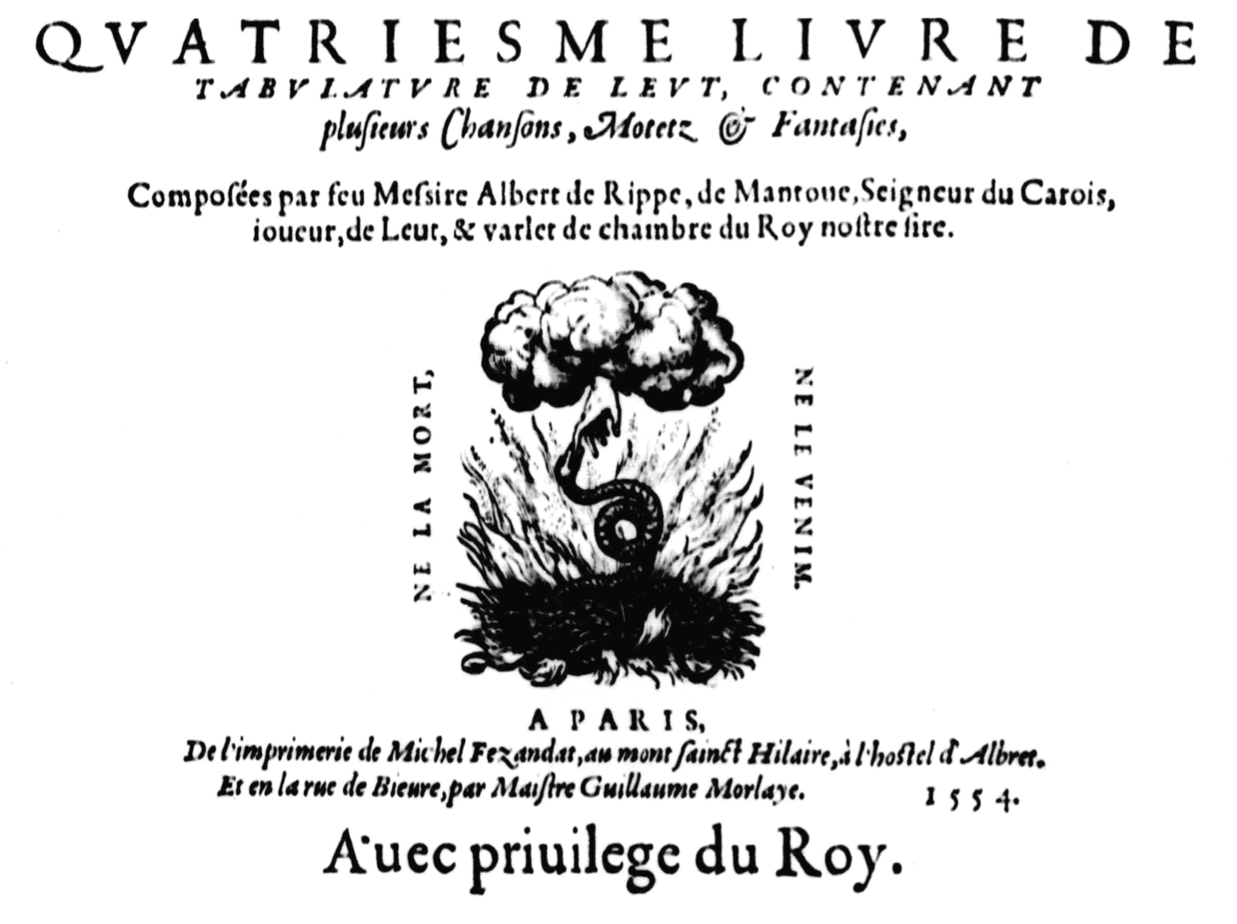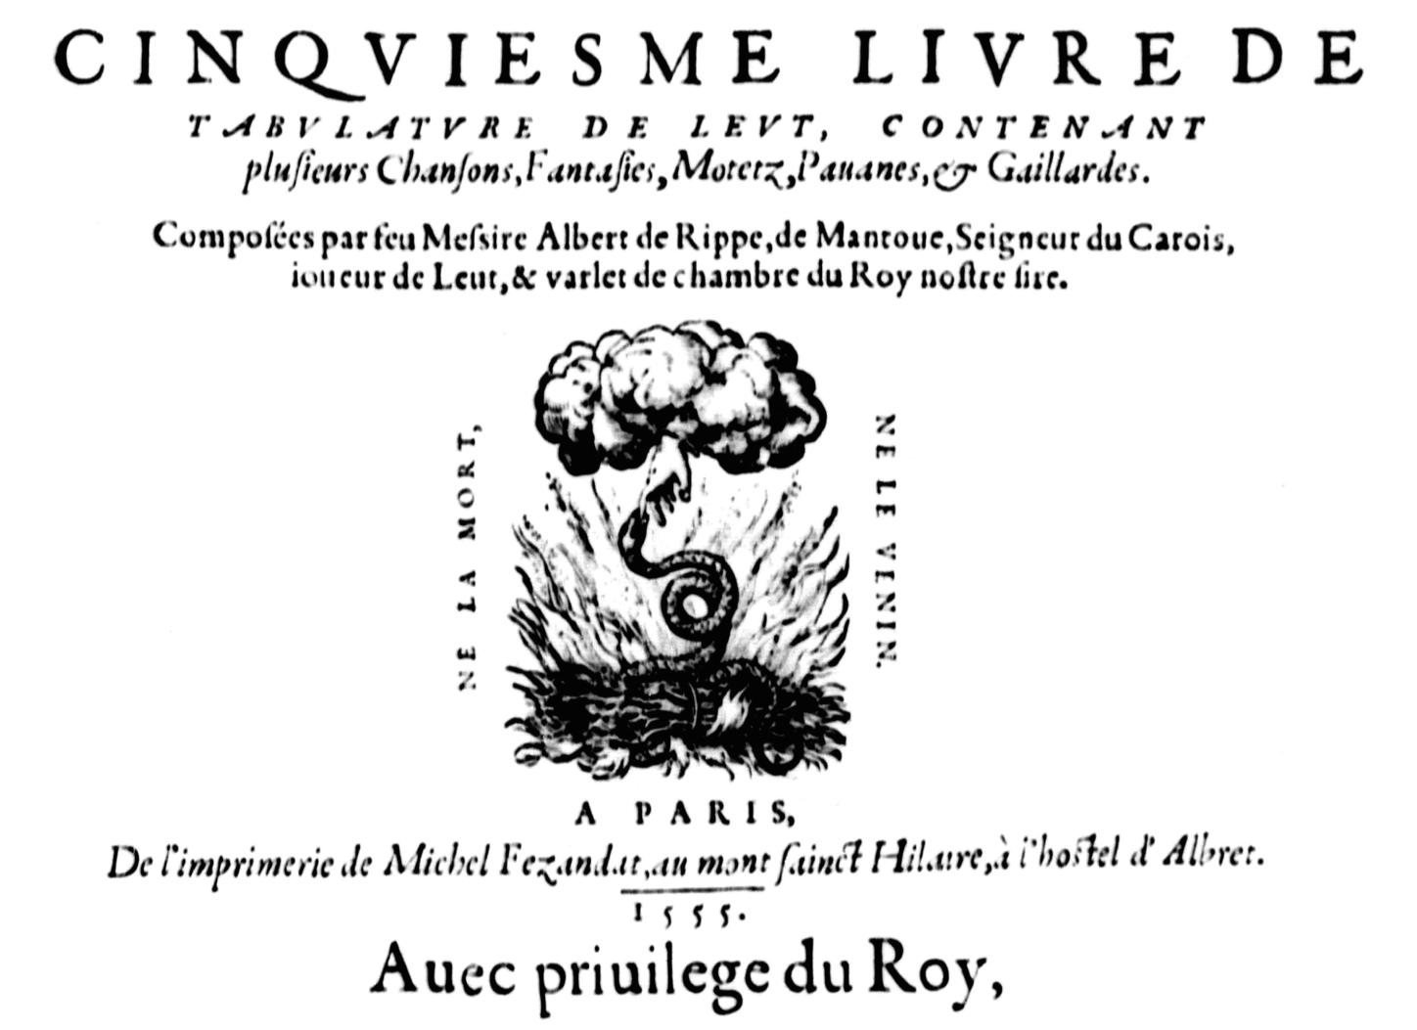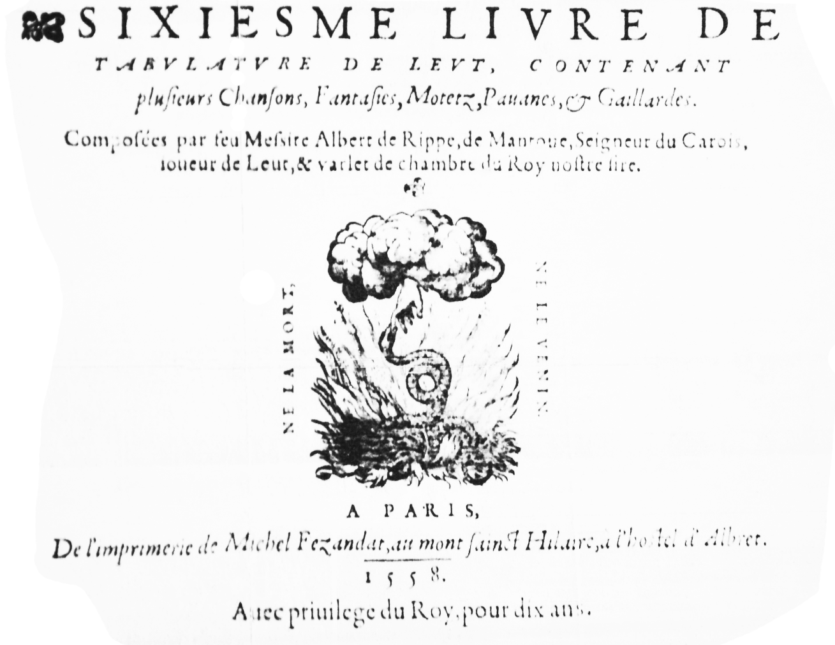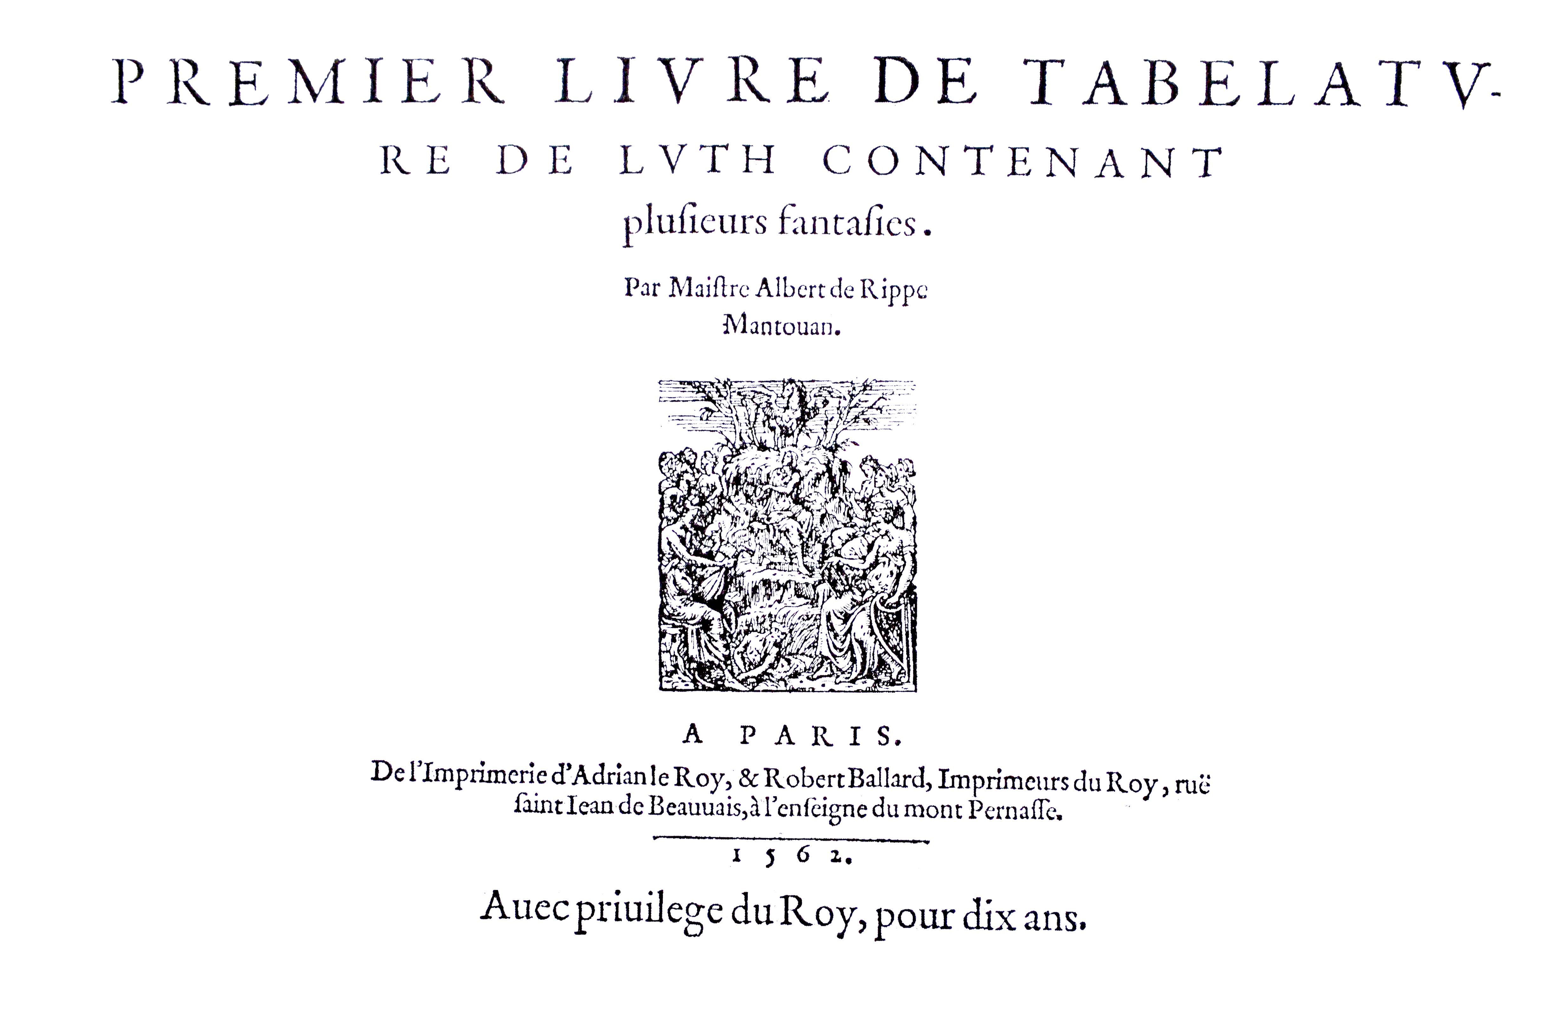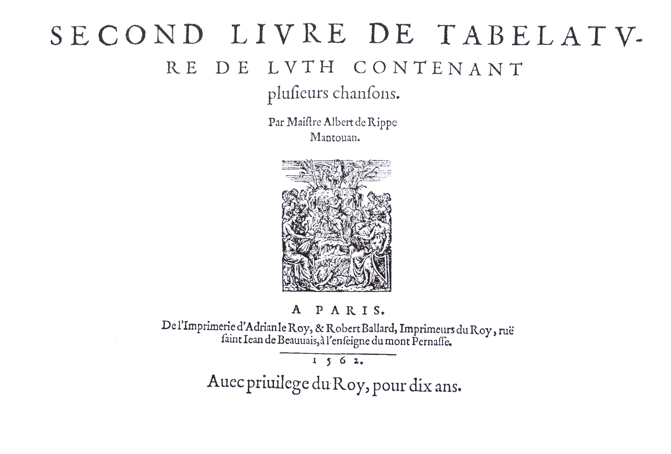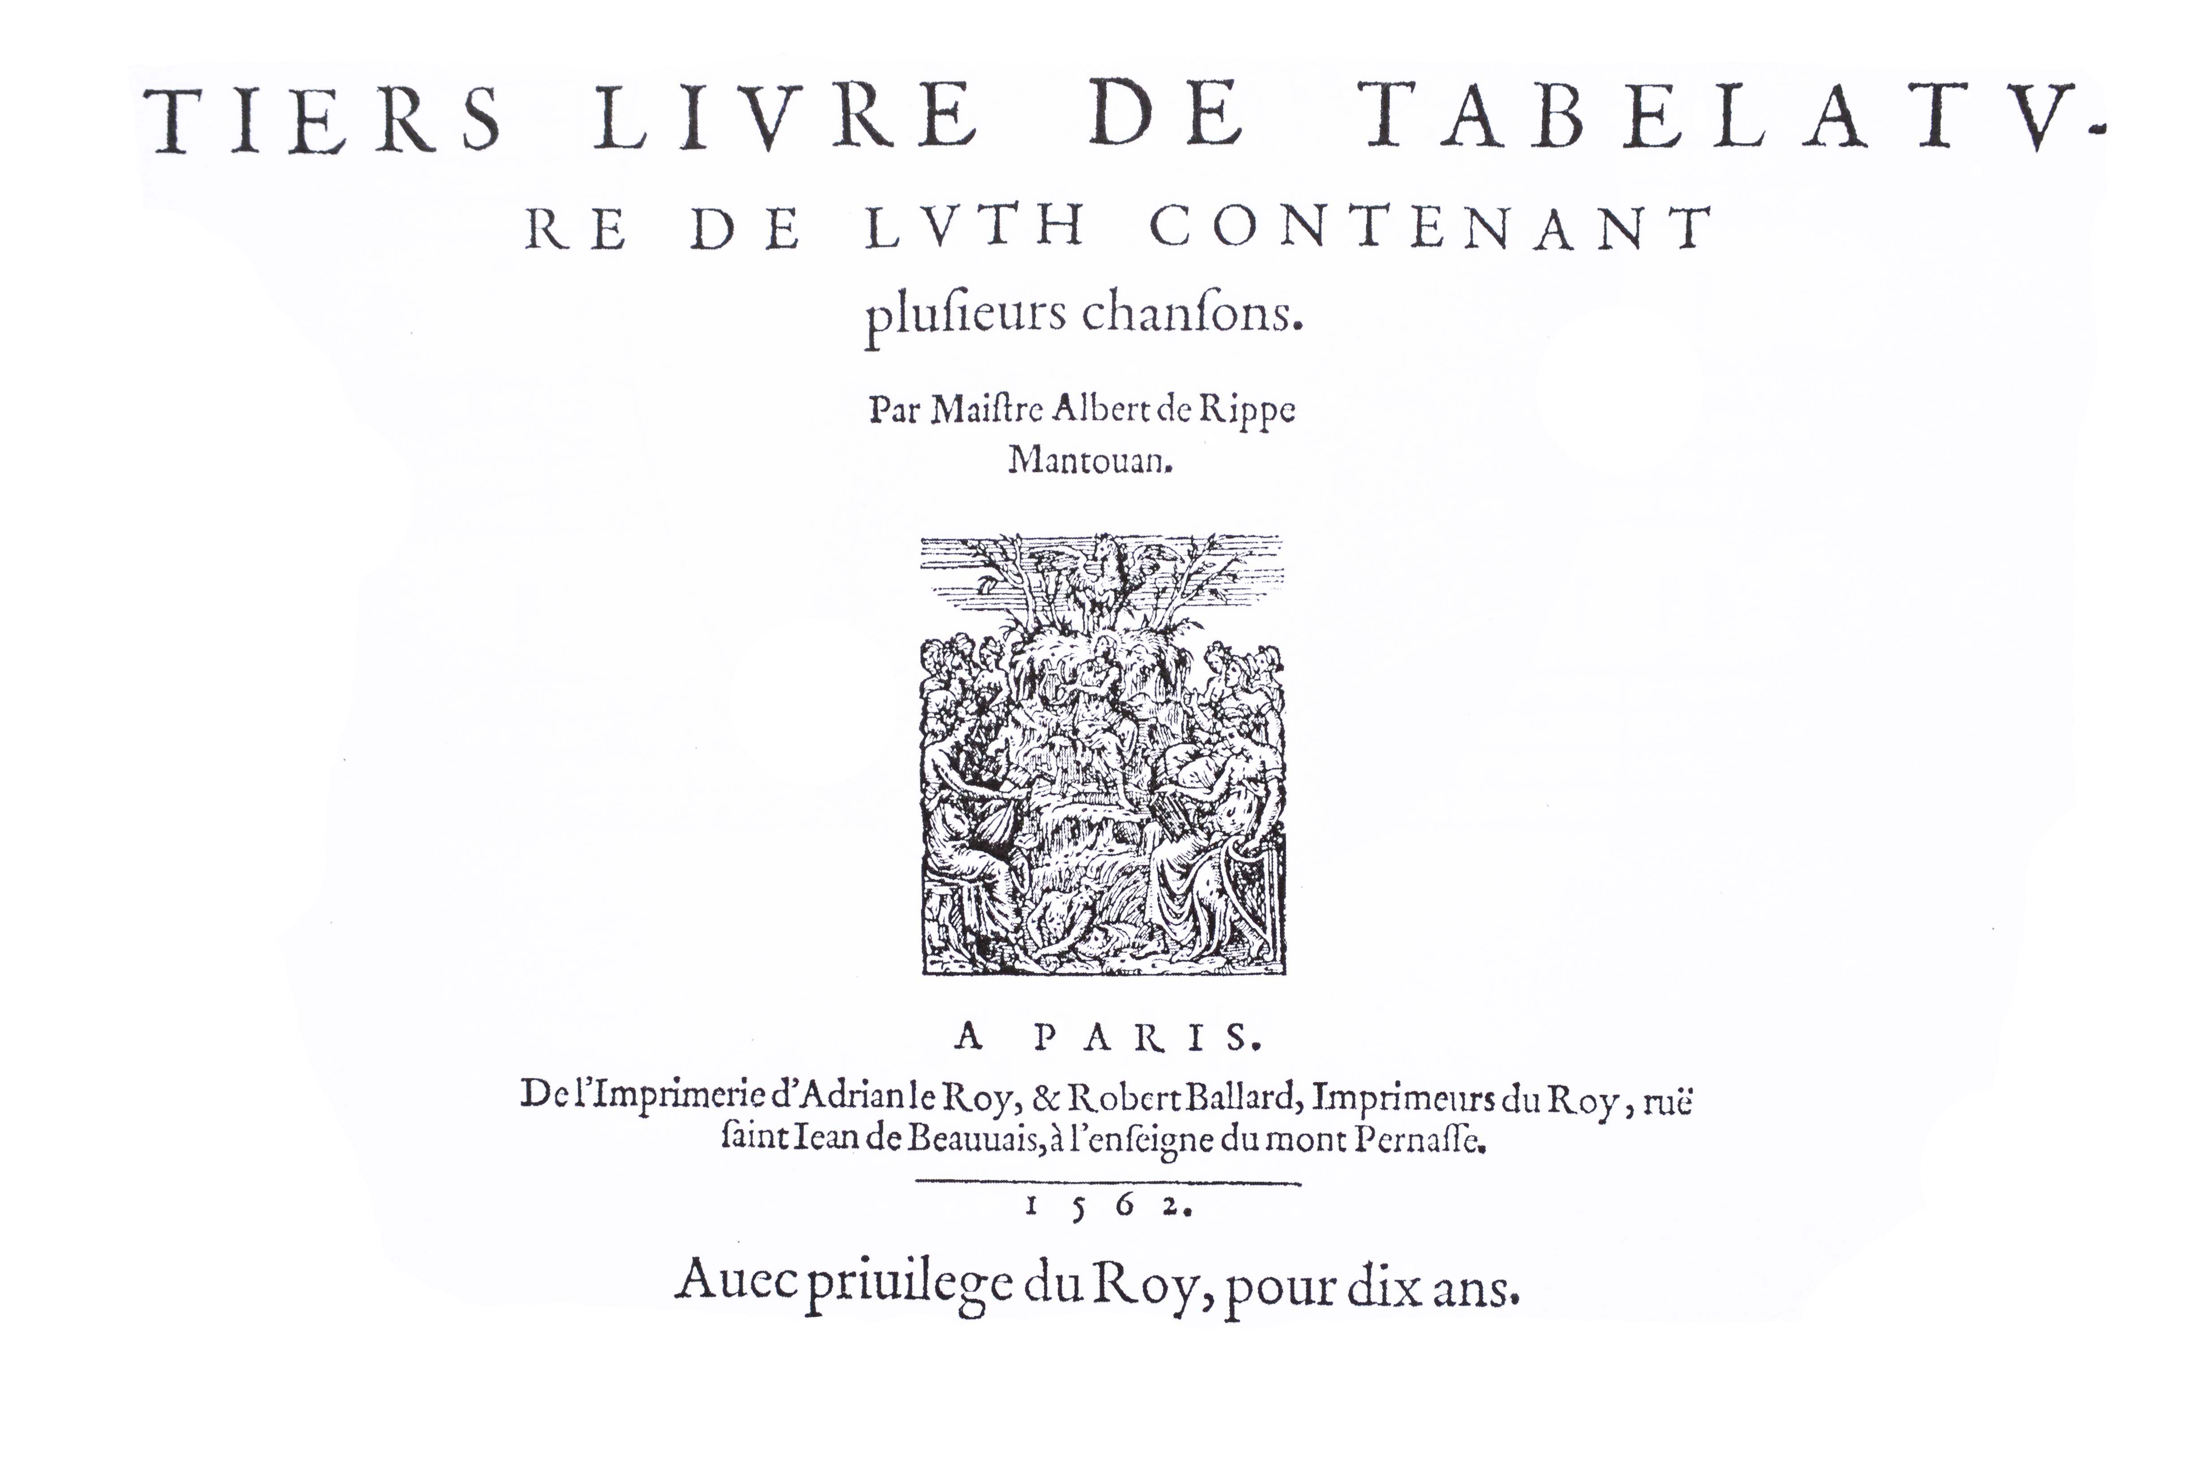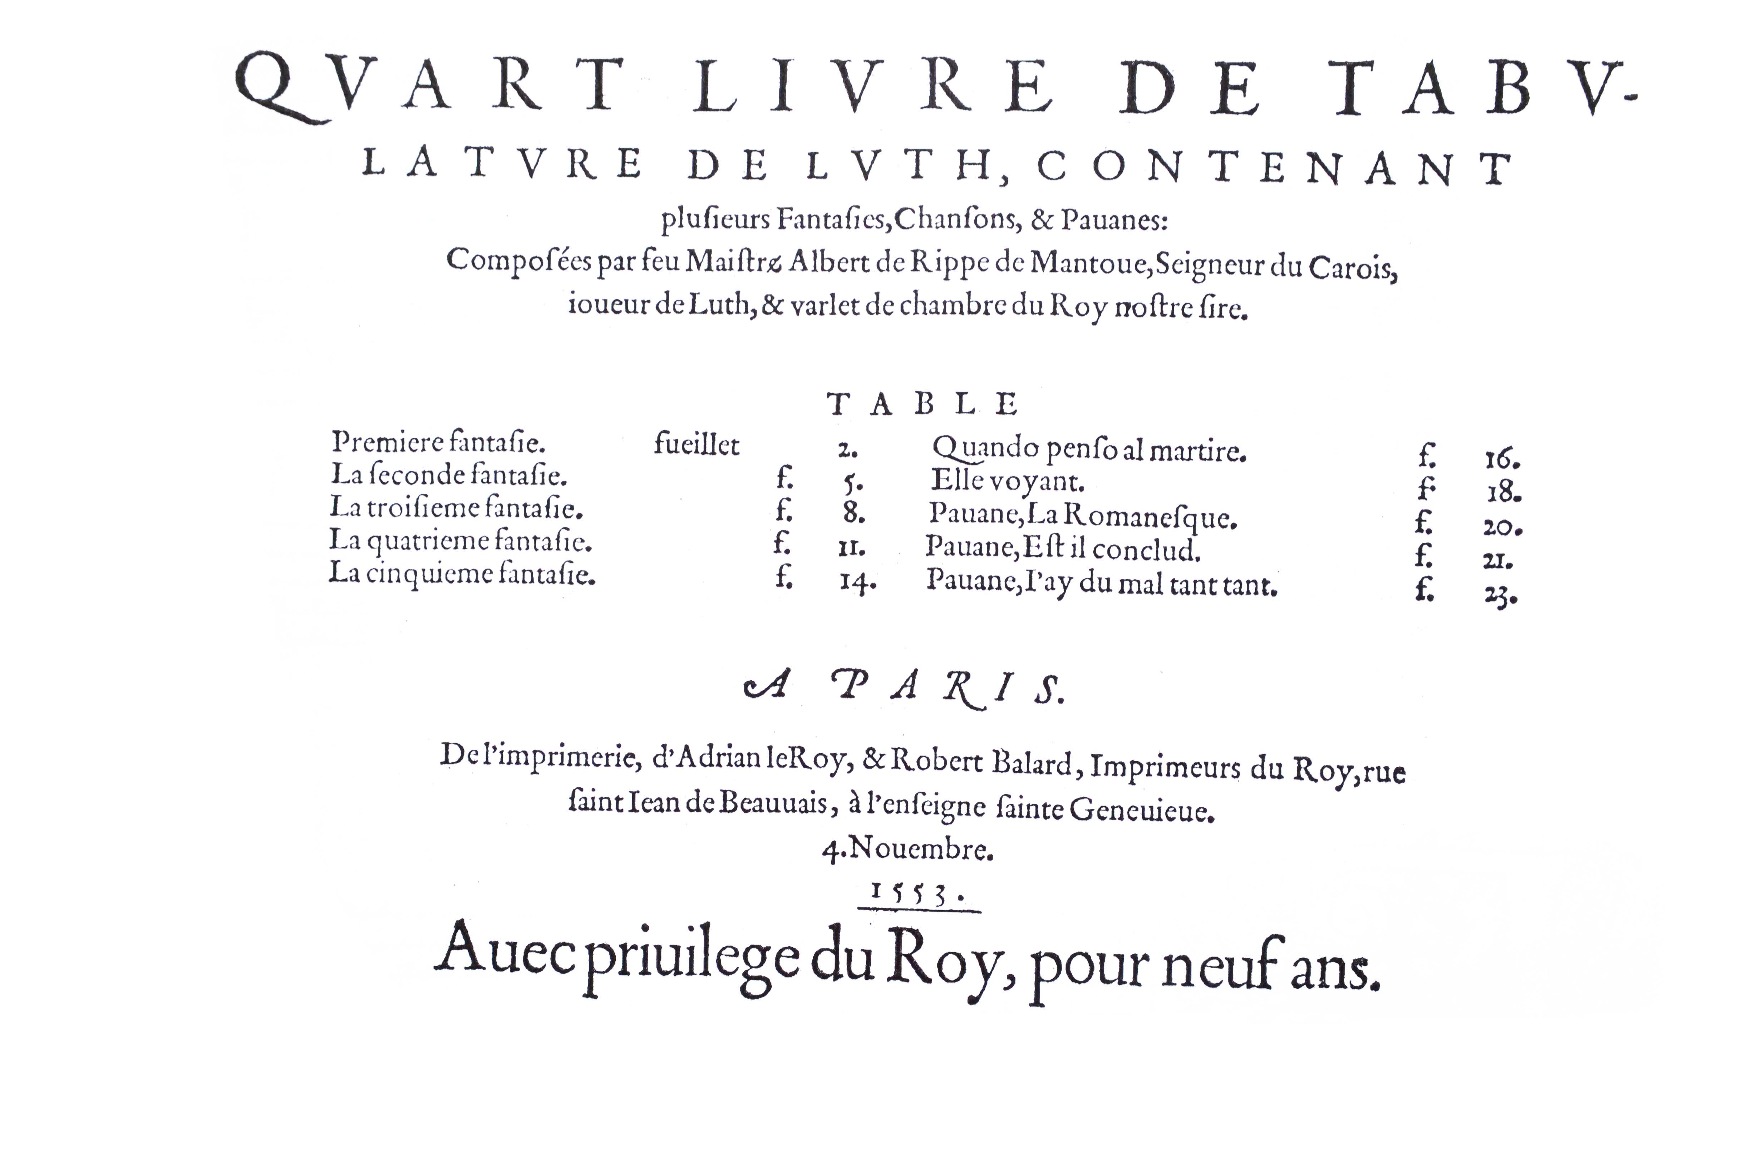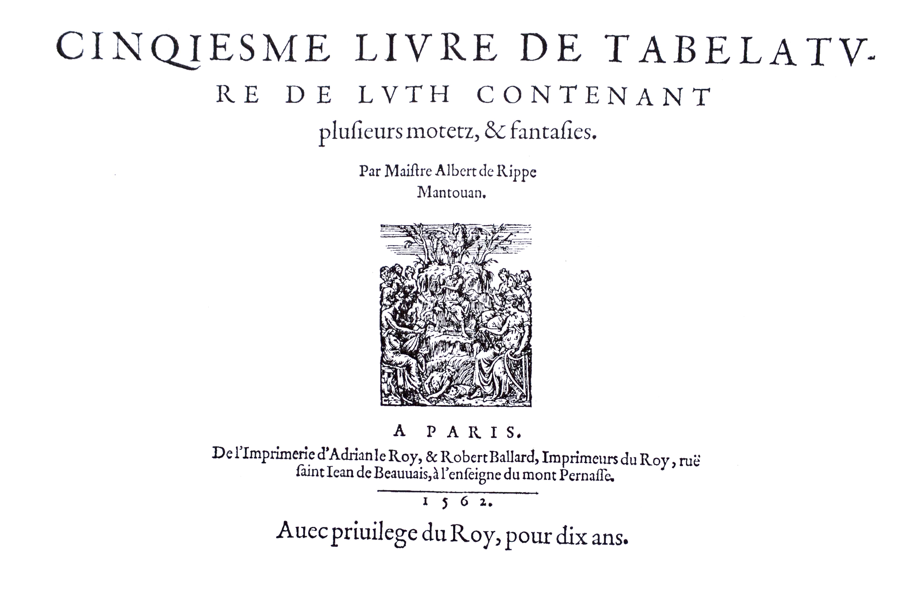

1. Santino 1-23 are in the accompanying *Lute News* 110, where the sources are described; S numbers are from the modern edition of Dieter Kirsch (ed.) *Santino Garsi da Parma Lautenwerke*, Guitarre & Laute 148 (Verlag, Koln, 1989), and O numbers from the modern edition of Helmuth Osthoff (ed.) *Der Lautenist Santino Garsi da Parma* sections I/II/III/IV (Leipzig, 1926/R1973). Here are further concordances from a lute book in Lucca, I-Lg 774, for no 1, ff. 29v-30r *La Chioccia Gagliarda*; for no 5, ff. 40r-40v *Lanfredina gagliarda / Lanfredina gagliarda*; for no 6, ff. 28r-28v *La Corabona Gagliarda*;and for no 15, f. 29r *Gagliarda*. Also no 16 is concordant with Adriaenssen *Novum Pratum Musicum* 1592, f. 57v *Galiarda Prima* [plus 2 mensural parts], and no 23 with I-Fn Gal 6, p. 254 ii *20*.
2. Commentary: All the Santino pieces have 1 or 2 dots for right hand fingering. **24i.** A8B8C8; 7F8Eflat9D10C; 3/2 & 7/2 - crotchets absent; 4/1-2 - bar line added; 12/2 - a5 instead of a4; 24/1 - fermata absent. **24ii.** adapted for 6-course lute. **25.** A8B4C8D12; 7F; T. for trill represented as # here; 6/1, 14/1, 18/1 & 30/1- crotchets instead of dotted crotchet; 7/3-4 - bar line added; 11/1 - quaver absent; 12/1-2 & 20/1-2 - minim crotchet instead of 2 crotchets; 21/4 - crotchet absent; 26/1&3 dotted crotchet and crotchet absent; 27/3 - quaver instead of crotchet; 32/before 1 - d3 crossed out; 32/1 - crotchet absent; 32/3 - fermata absent. **26.** A12B106; 7F; 3/5,s 6/5, & 26/7 - 12-13 - bar line absent; 20/1 - d4 crossed out; 22/3-4 double bar line absent; 28/3 - fermata absent. **27.** A8B8C4D4; 7D; bar lines and changes to the rhytm and tablature reconstructed from concordant version; 4/3, 8/3, 12/3, 16/3 & 24/3 - minims instead of semibreves; 5/1 - d2d3a4 absent; 7/1 - minims absent; 13/1 - a5 instead of a3; 14/3 - c6 instead of a6; 14/4 - d1a2b3 absent; 15/1 - c1c2d3c6 absent; 15/4 & 23/4 - crotchets absent; 18/1-2 - d3a5-c4 absent; 19/5 - minim a note to the left; 20 - 2 crotchets minim instead of dotted minim crotchet semibreve. **28i.** 6 sections of 8 bars, double bar lines absent except vertical row of dots at 40/1-2 and double bar line added at 48/1-2; 7F8Eflat9D10C11Bflat 12A; curved line for run articulated with left hand and tenuto signs x; 5/1, 9/1 - crotchets absent; 17/1 - minim absent; 18/1-2 - bar line crossed out; 48/1 - minim absent. **28ii.** Adapted for 6-course lute. **29.** 6 variations of 8 bars; bar lines absent (except single bar lines at 8-9, 16-17, 33/2-3 & 40-41); [7D]; 1/1 & 44/8 - minims absent; 7/5 - crotchet instead of quaver; 10/1 - quaver a note to the right; 20/9 - a5 2 notes to the right; 22/9 - a6 instead of a7; 22/11 - e6 instead of c6; 23/7 & 38/13 - crotchet absent; 33/6 - dotted minim instead of crotchet; 38/14 - d2 instead of d3; 39/4 - d2 instead of e2; 39/5 & 47/1 - quavers absent; 48/1 - c3 instead of c4. **30a**. A16B16; 24/1 - scribe altered b3 to d3; 32/1 - fermata absent. **30b-30u.** All versions are included but without a commentary, although changes are shown in grey. **31.** 7F; bar lines absent after 16; gridiron rhythm signs used here to clarify beats; 17/1 - f2 changed to h2; 32/4 - a1 absent; 33/8 - a4 changed to c4; 37/4-5, 38/4-5, 39/4-5, 52/4-5, 79/2-3, 120/2-3 & 121/2-3 - quavers changed to semiquavers; 39/2 - dotted crotchet d1b5 changed to crotchet d1; 39/3 - dotted crotchet c1a2c5 absent; 39/4 - b1 added; 45/5 - c2 changed to b2; 52/8 - a1a2 changed to a3; 59/3 - a2 added; 69/3 - c1 changed to f1; 70/1 - c5 4 notes to the left; 70/15 - a1 changed to e1; 71/15 - crotchet changed to quaver; 76/5 - a1 absent; 77/5 & 78/4 - quavers changed to crotchets; 78/3-4 - d1b3 changed to c1a2b4-f1; 79/4 to 80/4 - quavers changed to crotchets; 94/6 - e1 changed to e2; 99/6 - a2 changed to a1; 101/3 - a1 absent; 101/6 - a1 changed to c1; 101/after 8 - h1 added; 102/1 - h1 absent; 110/2 - d5 changed to e5; 119/9-12 - crotchets changed to quavers; 122 - c5a6 absent. **32**. 6-c; bar lines absent; 4/4, 17/2, 19/2, 22/2, 26/4 - crotchets absent; 12/2 - d3 instead of c3; 28/1 - crotchet a note to the left; 32/5 - a6 absent; 40/2 - c2 instead of d2; 41/6 - e1 instead of a1; 45/3-4 - c4-a4 absent; 53/6-7 - a1-e2 absent; 54/5 -crotchet instead of minim at beginning of new stave; 53-61 - rhythm signs absent (except crotchets at beginning of new staves); 60/4 - a3 added. **33.** A10BB6C6D6E5E4C6D4; double bar lines absent; a curious structure with bars 1-4 in triple time and from bar 5 in duple time; 6-c; 5/5-6 - c1-d1 absent; 10/1 - dotted minim instead of semibreve; 16/5-6 - c2-a2 covered with ink blot; 17/2 & 51/4 - a4 added; 30/4 - a4 instead of a3; 31/3 - d2 instead of c2. **34.** A6B8C8; 7D; 21/3 - dotted quaver instead of quaver.
3. Cognate settings: A-KR L64, f. 31r *Ballo di firenze* [4 bar fragment crossed out]; A-KR L64, f. 31v *Ballo di Firenze*; A-KR L64, f. 33r *Corrente francese in aria del ballo di firenze ~~Saltarello~~*; A-KR L64, f. 33v *Saltarello del ballo del’ grand Duca*; A-KR L64, f. 36v *Basso per il chitarrone Ballo dell’ Gran Duca* [bass part in mensural notation with 2 variations]; A-KR L81, f. 121v *Aria di Fiorenza*; A-KR L81, f. 122r *Aria di Fiorenza in Tripola*; A-KR L81, f. 122v *Variatio*; B-Bc 26.369, ff. 2v-? untitled; B-Br 16.663, f. 17v untitled; D-B 4022, f. 13r ii *Balletto de florenza*; D-B 4022, f. 40r ii *Curanto*; D-W Guelf 18.8 IX, f. 3r *Ballo del granduco di Fiorenza*; D-W Guelf 18.8 IX, f. 3v *Il medesimo ballo pi facilmente*; I-BRfranchi, f. [17v] *Bal del duca a balletti balletto in soprano*; I-BRfranchi, f. [20v] *Ballo del duca in tenor*; I-Fn Magl.XIX.105, f. 14v *Ballo di Palazzo*; I-Fn Magl.XIX.106, f. 6v *Ballo di Palazzo*; I-MOs Busta IV B, f. 21v *Aria di Fiorenza AP*; I-MOs Busta IV B, f. 22r *arpeggiata ATP*; I-Nc 7664, f. 17v *Ballo di Palazzo*; I-Nc 7664, f. 74r *Aria di Palazzo*; F-Pn Rés.941, f. 22v Aria *de duca* fio*re*[n]*za*; F-Pn Rés.941, f. 23r Ba*llet de fiore*[nza]; F-Pn Rés.Vmd.29, f. 8r *Aria di Fiorenza* [accompaniment?]; F-Pn Rés.Vmd.29, f. 10r *Aria diel Gran Duca in 2o tuono*; F-Pn Rés.Vmd.29, f. 13r *Aria diel Gra*n *Duca in P*rim*o tuono*; F-Pn Rés.Vmd.29, f. 13r *Aria diel Gran’ Duca in p*rim*o t*[uon]*o*; F-Pn Rés.Vmd.29, f. 13r *Rotta del Aria diel Gran’ Duca in p*rim*o t*[uon]*o*; F-Pn Rés.Vmd.30, f. 19r *Bal del duca*; F-Pn Rés.Vmd.30, f. 20v *Bal del Duca*; F-Pn Rés.Vmd.31, f. 1v *Ballo del gran Duca*; F-Pn Rés.Vmf.50, f. 7r *Ballo di Palazzo*; I-PESc b.14, f. 5v *Aria del gran duca N. C.* [theorbo]; I-PESc b.14, f. 18v *L’Aria di Firenza - L Rocta di Firenza*; US-SFsc M2.1 M3, p. 20 *Aria del gran ducha di toschana in dialogo*; US-SFsc M2.1 M3, p. 81 *Aria del gran Duca in tenore*; I-TRa w.s., , f. 3v *Bal del gran Ducha*; I-TRc 1947, f. 15r *Balo del gran duca*; I-TRc 1947, f. 15v *Corenta del granduca*; I-Vnm IV.1793, f. 6v *Aria fi fiorenza - Rotta*; PL-Kj 40032, p. 390 *Ballo di fiorenza*; PL-Kj 40032, p. 391 *Volta del Ballo di fiorenza*; PL-Kj40153, ff. 7r-8r *Ballo del Gran Duca fatta da Santino Garsi*; PL-Kj40153, f. 23r untitled; PL-Kj 40591, f. 11v untitled; PL-Kj 40591, f. 24v ii untitled [with 3 variations]; PL-Kj 40591, f. 26v untitled [duet with 5 variations]; US-BE 757, f. 16r-15v *Ballo del Duca*; US-BE 760, f. 24 *Aria del Gran Duca di Toschana*; US-BE 762, f. 2v *Balletto del Ducha*; Caroso 1600, f. 116r *Laura soave*; Kapsberger 1604, f. 28r *Aria de Fiorenza*; Caravaggio 1607, pp. 24-26 *Balletto detto Alta Carretta*; Caravaggio 1607, pp. 26-28 *La sciolta della Sonata*; Gardano 1611, pp. 21-23 *Aria del gran duca*. Organ: Sweelinck, ff. 35v-37r *Balleth del granduca*. Baroque guitar: Calvi 1646, ? *Aria di Fiorenza* -- *sua corrente*; Corbetta 1639, ff. 52r-55r *Aria di Fiorenza sopra l’A*; Corbetta 1639, f. 56r-57r *Aria di Fiorenza sopra G*.
4. Cognate settings: A-KR L81, f. 128r *Ruggiero*; B-Br 16.662, f. 2r *Ruggiero*; B-Br 16.663, f. 20r *Rugiero* *P*(rimo); CND-Mc ms w.s., f. 94v *Ruggier*; D-B 40068, ff. 3v-4r *Rugiero* - untitled - untitled; D-Ngm 33748 II, f. 3v *Ruggieri*; D-Ngm 33748 II, ff. 4v-5v *Ruggieri* 2do 3o; F-Pn Rés.941, f. 2r *rugier*; F-Pn Rés.941, ff. 2v-4r (Rugi)*er rugier rugier siciliana* (Ru)*gier ..n ..ano* (Ru)*gier* (Rug)*ier* (R)*ugier*; F-Pn Rés. 29, f. 6v *Ruggiero*; F-Pn Rés. 29, f. 11r *Ruggiero in 6o tono*; F-Pn Rés. 29, f. 11v *Ruggiero*; F-Pn Rés. 29, f. 11v *Ruggiero*; F-Pn Rés. 29, f. 12r *Ruggiero*; F-Pn Rés. 29, f. 12r *Rotta del Ruggiero*; F-Pn Rés. 29, f. 12v *Ruggiero in po t*(on)*o Ruggiero in 2o t*(on)*o*; F-Pn Rés. 29, f. 14v *Ruggiero*; F-Pn Rés. 29, f. 16v *Ruggiero*; F-Pn Rés. 29, f. 16v *Ruggiero*; F-Pn Rés.31, ff. 32v-33r *Rugero*; F-Pn Rés. 941, f. 2r *rugier*; F-Pn Rés. 941, f. 2r *rugier*; F-Pn Rés. 941, ff. 2v-3r (rugi)*er*; F-Pn Rés. 941, f. 3r *rugier*; F-Pn Rés. 941, f. 3r *rugier siciliana*; F-Pn Rés. 941, f. 3v (ru)*gier* ...*n* (sicili)*ano*; F-Pn Rés. 941, f. 3v (ru)*gier*; F-Pn Rés. 941, ff. 3v-4 (ru)*gier*; F-Pn Rés. 941, f. 4r (r)*ugier*; GB-WMl 7, f. 81r untitled; I-Bc AA 360, f. 87v *Ruggiero nel Leuto*; I-BR private Franchi, ff. 22v-23r *Rugiero in soprano -- Rugiero in corenta*; I-Fn Magl.XIX 105, f. 17r *Ruggieri*; I-Nc 7664, f. 72v *Ruggero*; I-PESc b.10, f. 25r *Ruggiero Francese*; I-PESc b.14, ff. 4v *Ruggiero Ruggiero Ruggiero* (theorbo); I-Ra 1608, f. 28v untitled treble and ground; I-Rvat 4145, ff. 4r-7v untitled (Kapsberger); I-TRc 1947, f. 6v *Rugiero pr*(imo); I-TRc 1947, f. 14v *Rugiero*; I-Vnm IV.1793, f. 26r *Ruggiero*; PL-Kj 40032, pp. 336-338 *Ruggieri*; PL-Kj 40153, f. 3r *Ruggier* (ground?); PL-Kj 40591, f. 13v untitled; PL-Kj 40591, f. 24r untitled; US-BE 757, f. 8r *Rugiero baleto*; US-BE 757, f. 31v untitled; US-BE 759, f. 2v *Ruggiero*; US-BE 760, f. 21r *Ruggier p*(rim)*a*; US-BE 761, f. 1v *Ruggiero*; US-BE 761, f. 5v *Ruggiero baletto*; US-BE 762, f. 3r *Ruggier*; US-SFsc M2.1 M3, pp. 86-87 *Ruggiero Ruggiero in tripola*; Valderravano 1547, f. 24r *Rugier qual sempre fui tal*; Kapsberger 1604, pp. 15-18 *Ruggiero*; cf. Rogero: GB-Cu 8844 (Trumbull), f. 25v untitled (treble and ground duet John Johnson; JohnsonB 61) = GB-Cu Dd.3.18, f. 1r *Rogero Jo: Johnson* (treble) = GB-Lam 601 (Mynshall), f. 3v *The heare trebble of Rogeroe* (treble) = IRL-Dtc 410/I, p. 92 *Rogero to the grounde* (ground) = NL-Lu 1666 (Thysius), ff. 383r-384r *Rogier* (treble); GB-Lam 602 (Sampson), f. 3v *Rogero* = GB-Lam 603 (Board), f. 2r *Rogero*; IRL-Dtc 408/II p. 91 *Rogero qd Jo Johnson* (fragment; JohnsonB 33); IRL-Dtc 410/I, p. 20 *ROGERO*; IRL-Dtc 410/I, p. 21 *the Division of RoGero before*; IRL-Dm Z.3.2.13 (Marsh), p. 305 untitled. Keyboard: Ortiz 1553, p. 134 *Quinta pars*; Henestrosa 1557, f. 67r *Rugier Glosado De Antonio* (Cabezon).
5. Christian Zimmermann *Lautenmusik aus Italien* (Antes Edition, BM-CD 31.9030, 1993) no 24, 25 & iii; Konrad Ragossnig *Musik für Laute II: Italien* (Polydor Archiv 2533 173, 1974) - vinyl LP, not included in the selection from the series I-V remastered on CD as *European Lute Music* (Deutsche Grammophon Eloquence 469 679-2, undated) no 5, 8, 12, 14, 23, 27 & 29; Arto Wikla on YouTube:

   https://www.youtube.com/watch?v=CnGdiYv75Q8 - for no 23

   [ditto]=xwsORCTmS5U - for no 27 & [ditto]=GrkuKeEu_PM - for no 29.
6. Duke of Parma, Ranuccio I Farnese (1569-1622).
7. The name in the title is presumably a dedication rather than composer, and in the facsimile edition of the ML lute book (Clarabricken, Boethius Press 1985) p. xxii, Robert Spencer suggested it referred to Arthur Brett, a cousin of Lady Buckingham, Groom of the Bed-chamber and would-be favourite of of James I, who was knighted in 1623 and came to public notice especially in 1624, or alternatively Robert Brett of Devonshire who was knighted in 1604 and died in 1620.
8. Mariagrazia Carlone, ‘The Knights of the Lute’ *Journal of the Lute Society of America* xxxvii (2004), pp. 1-125 and ‘The Knights of the Lute: Musical Sources’ xxxviii (2005), pp. 1-45 [numbers here from the catalogue]. Thanks to Grazia for sharing her edited version of the Cappriccio.
9. Commentary: All for 6-course lute. **i.** A12B10C8; double bar lines absent; no changes. **ii.** A8B4C6; 13/before 1 - minim a1b2d5 and bar line added; 18/2-3 - double barlines added. **iii.** A8B8A8C8B8; 32/1-2 - double bar lines absent; tenuto sign +; no changes. **iv.** A10B10CC8; double bar lines absent; 11/5 - c2 instead of d3. **v.** A19B8B26; double bar lines absent; 9/5-6 - bar line crossed out; 10/7-8 - bar line added; 17/3 - a1c2 instead of c1; 17/5 - scribe altered a1 to c1; 18/4 - e1 crossed out; 19/1 - minim instead of dotted minim; 22/6 - c2 instead of c3; 22/7 - d3 absent; 24/3 - b1 instead of a1;24/between 4-5 - b1c3 crossed out; 26/5 - e2 crossed out; 28/1 - a7 absent; 32/1 - e3 instead of d3 and e4 crossed out; 32/5 - e3 instead of d3; 35/1 - scribe altered crotchet to minim; 35/6-7, 36/5-6, 37/5-6, 39/3-4 & 40/2-3 - bar lines added; 35-36, 36-37 & 37-38 - bar lines crossed out; 37/2 to 38/1 - rhythm signs added later; 40/3 - crotchet minim crotchet added later instead of 3 crotchets here; 40/7 - quaver absent; 49/3, 5 & 6 - a5? crossed out; 54/3 - crotchet instead of minim. **vi.** A6B13C8; 6/1 & 18/1 - minims absent; 18-19 - bar line absent; 27/2 - crotchet instead of fermata. **vii.** A14B24; 26/1-3 & 33/2 - a1a2b3b4d5 instead of a1b2b3d5; 36/2-3 - b2 instead of a2.
10. Lorena is the Italian exonym for Lorraine, so probably Charles III (1543-1608), Duke of Lorraine from 1545, or Henry II (1563-1624), Duke of Lorraine from 1608.
11. Commentary: all for 13-course archlute using some or all of the diapasons. 7th course notated as a instead of 7 and 10th course as X instead of 10. **Donino 1.** 7F8Eflat9D10C11Bflat12A13G; 1 and 2 right hand dots for index and middle right hand fingers and T. for trill represented by # here; rythm signs absent except minim at 1/1 and minim crotchet at 37/1-2; 2/4 - a7 absent. **Donino 2.** 7F9D10C; 1 and 2 dots for right hand fingering; 1/1 - semibreve absent; 2/1 & 3/1 - a7 c7 instead of a6 c6; 5/1 - minim instead of crotchet; 6/2-3 - bar line added; 12/1 - crotchet instead of minim; 13/1 - minim absent. **Donino 3.** A8B7C8; 7F8Eflat9D10C11 Bflat; curved lines under sequences to indicate articulating runs with left hand fingers without plucking with the right hand; 1/1, 3/1 & 5/1 - minim instead of crotchet; 2/2&7 & 6/2&7 - quavers instead of semiquavers; 4/1 - d1 crossed out; 9-13 - crotchets instead of quavers; 16/1 - quaver a note to the right; 22/2 - crotchet absent; 23/1 - fermata absent. **Donino 4/**JD54h. A8B6C8; 7F; 1 and 2 dots for right hand fingering; 2/1 & 10/1 - crotchets instead of dotted crotchets; 5/1 - crotchet absent; 18/4 - fermata absent. **Donino 5.** ABAC8; 7F8Eflat9D 10C11Bflat13G; 1 and 2 dots for right hand fingering; double bar lines absent; 2/1, 6/1, 10/1, 14/1, 16/1, 23/1, 29/1 & 30/1 - crotchets absent; 14/3 - quaver a note to the right; 14/between 3-4 & 25/between 3-4 - d3 crossed out; 17/between 1&2 - c1a7 added; 17/3 - quaver 2 notes to the right; 18/2-3 - bar line added; 22/1 - crotchet d2a9 absent; 23/3 - quaver a note to the left; 31/2 - c1d2d3a4 crossed out. **Donino 6.** A8B16C16; 1 and 2 dots for right hand fingering; double bar lines absent; 31/1 - b2 crossed out; 31/2 - b2 crossed out. **Donino 7.** A8B16C12; 7F8Eflat9D10C11Bflat; curved lines under sequences and 1 and 2 dots for right hand fingering; no changes. **Donino 8.** A16; 7F8Eflat9D10C11Bflat; 1 and 2 dots for right hand fingering; 13/2-3 - scribe crossed out crotchet and c6 14/3 - scribe crossed out crotchet and c6 and added c6 below following d3 maybe intending a bar of dotted minim 3 crotchets. **Donino 9.** AB12; A8B16C12; 7F8Eflat9D10C11Bflat; 1 and 2 dots for right hand fingering and T. for trill represented by # here; 10/2 - crotchet absent. **Donino 10.** A12; A8B16C12; 7F8Eflat10C; 2/3 - dot under d4; 11/3 - a1a2c3c4 crossed out and a1c2c3 added; 12/3 - fermata absent. **Donino 11.** A8B16C12; 7F8Eflat10C11Bflat; 1 and 2 dots for right hand fingering; 2/1, 5/1 & 6/1 - crotchets instead of dotted crotchets; 3/between 1-2 - a1 crossed out; 3/4, 5/3 & 6/3 - crotchets absent; 8/1 to 9/1 - minims absent; 16/3 - fermata absent. **Donino 12.** A16; 7F8Eflat10C; 1 and 2 dots for right hand fingering; rhythm signs absent except all the quaver position to imply the dotted rhythms adopted here; 8/1 - minim d2a7 absent. **Donino 13.** 7F; original divided by double bar line into 2 sections of 38 and 70 bars and other sections marked by text inserted on the staves: *Tamburi Per l'hordinanza* [bar 1]; *Trombe con il Tamburo* [6]; *risposta In ottaua* [13]; *Inuito delle Trombe* [20]; *risposta In ottaua* [24]; *risposta del Inuito* [28]; *risposta in ottaua* [32]; *Tamburi per la meza macchiata* [36]; *Tamburi con il Piffaro, sonato da un Thod*(es)*.co* [39]; *risp*(ost)*.a del Thodesco In ottaua* [45]; *La Girometta fatta dalle Trombe et Tamburi* [54]; *risposta della Giromet*(t)*a In ottaua* [62]; *Trombe per Innonimire li scaramuzanti* [70]; *Piffarea* *sonata con il Tamburo la Vitonia* [78]; *Tamburi per la ritirata* [104]; 6 & 70 - triple time signatures absent; 6/1, 39/1 - crotchets absent; 12/1, 19/1, 23/1, 27/1 - dotted minims instead of dotted semibreves; 47/2-3 - bar line crossed out; 50/3 - minim instead of semibreve; 78/1 - duple time signature absent. **Ascanio 1a.** AB16; 7F8Eflat9D13G; T. for trill represented by # here; 3 - bar absent; 7/1 - a1 added; 12/between 2-3 - c2d3 crossed out; 15/1 minim crossed out; 25/3 - c4 absent; 26/1 - c4 instead of b4; 27/1-2 - crotchet absent and b3-c4 crossed out; 28/between 4-5 - d2 crossed out; 29/3 - a2 absent. **Ascanio 1b.** AB16; 7F8Eflat9D; ornaments x & , ; 2/1 - a3 instead of a2; 8/3 - b1 instead of b2; 10 - bar absent added from concordant version; 24/3 - scribe altered b3 to d3; 26/2-4 - quavers absent.
12. Probably Ferdinando Gonzaga (1587-1626), Duke of Mantua and Montferrat from 1612. A villanella by Albert Dlugoraj in Besard 1603 f. 48r uses the same opening phrase.
13. François-Pierre Goy, *Gaultier-Verzeichnis* (forthcoming).
14. Cognate for Dowland's setting: GB-Och 1252, p. 31 *Dowlands Puffe* [recorder part for mixed consort c.1600].

    Commentary: No detailed critical commentary, but changes shown in grey. **JD54f.** A16B12C15D16E16; 7F; **JD54g.** AA16BB16C24D8E16; 7F; **JD54h.** A8B6C4; 7F8Eflat; **JD54i.** A8B8; 7F10C; **JD54j.** A8B8; 7F; **JD54k.** A8B6C4D4E4; 7F8Eflat; **JD54l.** A8B6C8D4E8; 7F10C; **JD54m.** A8B8C6D8E8; 7F; **JD54n.** AA8BB6CC4DD4EE4; 7F10C; **JD54o.** A8B6C3D?; 7F. Keyboard: I-Fn Magl.XIX.115, ff. 5r-5v *Aria franzese*.
15. Commentary: **22.** 89/1 - c5 instead of b5; identical to Phalèse except latter bars in 2 minims, lacks dots and sloping lines (tenuto), and changes one note, a6 instead of b6 at 92/4. **23.** no changes; identical to Phalèse except latter bars in 2 minims and lacks dots and sloping lines (tenuto). **24.** 8/2 - c4 absent; 65/1 - h3 instead of g3; 94/4 - d2 absent - thank you to Nigel North for suggesting the edits.
16. Brown 15539 - copies in B-Br, D-Mbs and D-ROu, the latter used for the facsimile (Lübeck, Tree Edition, 2009]. Numbering of fantasies from Jean-Michel Vaccaro *Oeuvres D'Albert de Rippe I: Fantasies* (Paris, CNRS 1972). Only no 22 of these three has been recorded as far as I know, by Hopkinson Smith CD *Tabvlatvre de Leut: Albert de Rippe* (AstréeE 7734, 1978) and Christopher Wilson *La Magdelena: Lute Music in Renaissance France* (Virgin Veritas 7243 5 45140 2 9, 1995).